Master Nelson,

I have completed a rewrite of the blog. I did review all of Steve’s suggestions and comments. I pretty much changed any grammatical or technical corrections, and in some places I took his advice to expand or go into more detail. On the first pass, I was afraid of including too much, so it was nice to have permission to go into more detail on some stuff. I did have a few areas where I did not take his suggestions, because I felt that I disagreed with his assumptions or approach.

I wanted to provide a little detail on some of my thoughts on why I didn’t make some changes, or just some things I want to be careful about:

1. The title – I changed it to Campus Safety for Women and Self-Defense (instead of Martial Arts). One of Steve’s comments was to clarify if marital arts and self-defense were the same thing, or if we needed to define the difference. I think they are separate concepts – and I changed my wording to just stick to the self-defense aspect and avoid having to go into a discussion of the differences – which seemed unnecessary for this blog. I don’t feel strongly about this though – so if you see it differently let me know.
2. He suggested we add the word “prevention” in a couple of places. I did include the word once or twice. However, I would like to be cautious about relying heavily on saying we are teaching women to “prevent” sexual/physical assault. Focusing on helping women “prevent” sexual assault places a lot responsibility on the victim to be the one to prevent an action that is not in her control (the assault). Assailants are the ones who are solely responsible, and prevention efforts would best be directed to farther reaching changes to the “rape culture” that Steve’s refers to. I would prefer to stick to reducing risks, or reducing chances, being prepared, etc. – that sort of language. I know it’s a minor nuance – but it hits me in the gut funny.
3. At one point he says that we did not have this kind of rape and highly sexualized culture when today’s kids’ parents went to school. I beg to differ. The issue is much more publicized today and gets much more attention from advocacy groups that are speaking out against university policies and responses. But I can speak from my personal college experience - the same culture totally existed when you and I were that age. If anything – there were just fewer resources if you wanted to pursue charges against an assailant, and fewer resources for learning effective self-defense.
4. He suggests that we post parts of the video I mention – I just wonder if there would be copyright issues with doing that without permission? I really don’t know – but just raise the question. I did name the specific video for reference though.
5. He didn’t want me to single out frats – I changed the wording a bit here to be more inclusive of settings outside of frats – but just an FYI, statistics do show that fraternity men are 3 times more likely to commit sexual assault than other college men.

I really liked a lot of his ideas about marketing – and have had some similar ideas to the ones that he suggests. I’m looking forward to working on this!

**Campus Safety for Women and Self-Defense**

The school year is winding down, and recent high school graduates will be turning their attention to preparing for college in the fall. College is an exciting, brand new adventure for incoming freshmen. What will your classes be like? Will you get along with your roommate? What will you major in? It is also an exciting, and scary, time for parents. Will my child do well? Will they be able to manage the increased independence? And for the parents of young women – will they be safe from possible sexual assault? How can I help them be prepared to protect themselves?

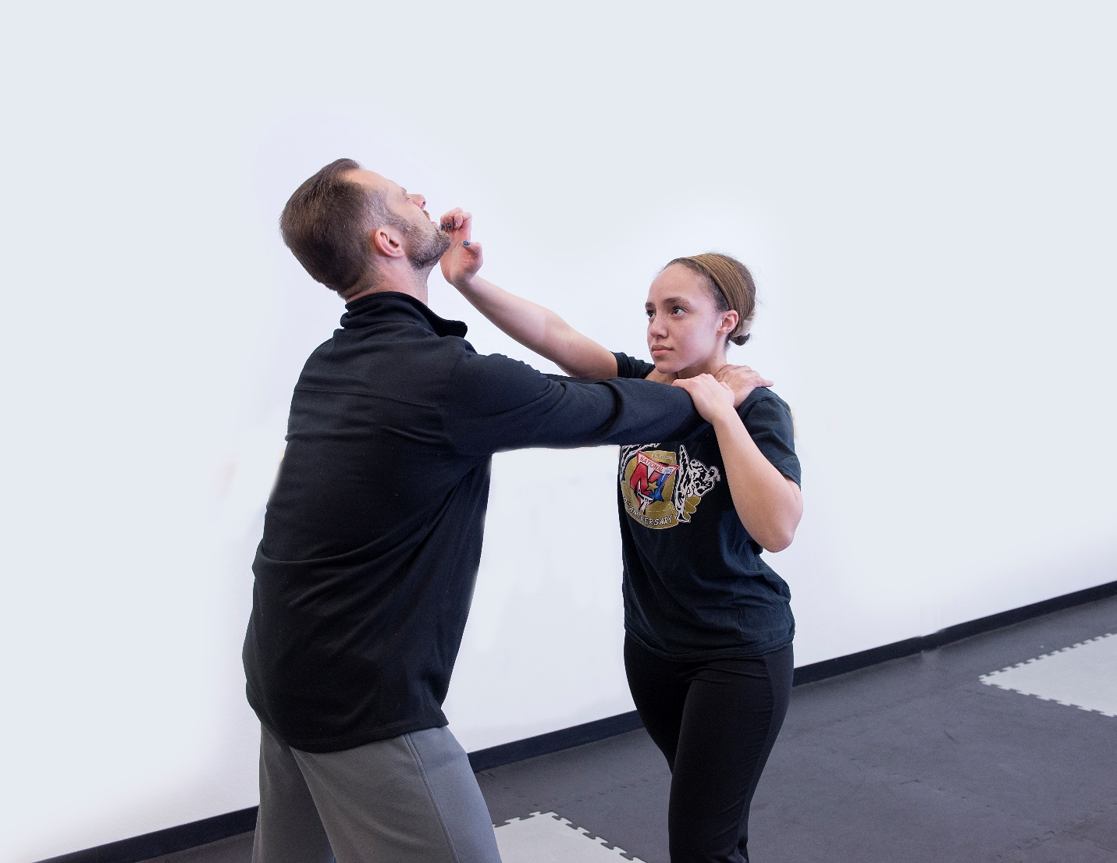

In recent years, there has been greater attention on the prevalence of sexual assault at our nation’s colleges and universities. Multiple studies and reports state that at least 1 in 5 college women will experience some form of sexual assault while at school (Journal of American College Health, 2009, Washington Post – Kaiser Family Foundation, 2015, & White House Task Force to Protect Students from Sexual Assault, 2014). Sexual assault can include a wide range of forced, unwanted, or coerced sexual contact or behavior including kissing, groping, and rape. Universities have faced criticism for not taking victims’ complaints seriously, and imposing few, if any consequences on perpetrators – even allowing perpetrators to remain on campus where they may assault again. Universities have also been accused of under reporting rates of sexual assault to protect the reputations of their schools, and not doing enough to protect the safety of their students. It’s frightening to think of sending our daughters off to this kind of environment unprepared.

At National Karate we will start getting calls in the summer from parents who want to help their daughters reduce their chances of being assaulted. We will offer classes dedicated to teaching self-defense skills and focusing on ways to increase safety specifically in the college setting. We will also visit high school seniors in several local high schools in the spring to discuss prevention, safety tips, and strategies. Seniors who attend these classes can also take advantage of an offer for a free month of marital arts classes to help them practice and learn additional skills before they go off to college.

Experts agree that self-defense training is a valuable tool in sexual assault prevention, and studies have shown that women who have received training are less likely to be victims of assault. Effective women’s self-defense training can increase assertiveness, perceived control, self-efficacy, risk avoidance behaviors, confidence, and self-esteem (Hollander, 204). Learning self-defense has also been demonstrated to help women feel stronger, and less anxious and fearful (Brecklin, 2008). All of this helps to make women less vulnerable to assault.

National Karate’s self-defense classes teach skills that help to prevent an assault from occurring, as well as ways to respond if an attack does occur. At least seventy-five percent of sexual assaults are committed by someone the victim already knows. This means for women at college, it’s not always a stranger coming out of the darkness that is the greatest concern, it can also be the guy they meet in class, in their dorm (many colleges have co-ed dorms where men and women share the same floor), or at a party. To effectively defend themselves, women have to be armed with confidence, and a cautious awareness of their surroundings and the behavior of other people. We teach women to trust their instincts if they feel uncomfortable, and leave situations when they feel threatened. We also provide training on ways to use body language and verbal skills in relationships to convey assertiveness, and establish boundaries which helps to minimize attempted assaults. We also discuss warning signs that a relationship may become abusive, and lead to physical or sexual violence.

The fact that women often know their attacker, does not mean the situation is less physically threatening. And there is also the threat of being assaulted while out on your own walking across campus, home from class, the library, or from a party at night. We teach techniques to respond to different physical attack scenarios such as being grabbed by surprise, held from behind, or choked by an attacker. We teach simple, and easy to remember techniques that increase a woman’s ability to respond effectively without “freezing”. We teach strategies that will work in situations even when an attacker is bigger, or physically stronger. The more exposure someone has to this kind of practice and training, the better prepared and capable they will be of fighting off an attack. When women have tools to physically defend themselves, they also feel more confident in their ability to respond if necessary.

When conducting self-defense classes for college-aged women, I’ve shown a short video called *The Undetected Rapist,* produced by Dr. David Lisak*.* It shows the reenactment of an actual interview with a male college student who describes how he sexually assaulted a freshman woman at a fraternity party. The perpetrator explains how he “targets” a freshman because he believes she will be more naïve. He invites her to a party, offers her drinks with a fruity flavor that mask the alcohol content, and takes her to an isolated room. The attacker does not define his actions as rape – even when he describes how he pins the woman down, with his arm across her throat, as she resists. One of the young women in my class reacted to the video by asking, “people actually DO that?!” Yes. And unfortunately, all too frequently. At least nine percent of college men admit to committing acts that meet the legal definition of either rape or attempted rape (Abbey & McAuslan, 2004). Of these men, many of them commit rape repeatedly (Lisak & Miller, 2002).



There are a number of factors that increase the risks of assault on college campuses. It is typically the first time young adults have lived away from home without adult supervision. Young adults are exploring relationships and trying to define what they want in a partner, and boundaries around physical contact and intimacy can be unclear or confusing. Alcohol consumption and binge drinking are common, and increase the likelihood of assault. Fraternities have faced increased scrutiny, and have been accused of fostering a culture that encourages a predatory approach to dating relationships - focused on “conquests”. Assaults are not limited to the fraternity system however, and that same predatory mentality can exist across the campus setting.

National Karate’s self-defense training helps to educate young women about all of these factors. We help them anticipate possible situations where they may be at risk, and encourage thinking through choices and options that can help keep them safe. We also help them to think proactively about what they want from a relationship and a partner, so they are better prepared to assert their own boundaries.

At National Karate we have girls and women who have been training with us for years. They have learned physical skills necessary to protect themselves. They have also gained confidence and a greater sense of personal efficacy that will help them reduce their risk of even being targeted for an assault. I have watched these young women go off to school, and I truly feel they are better prepared. Ultimately, we need to find ways to change the attitudes and behaviors that devalue and objectify women, and lead to a culture where violence against women exists. In the meantime, self-defense training can empower young women with strategies and skills that will help them protect themselves.